

P2PSIP and the IMS: Can they Complement Each Other?

Version 1.0

December 18-th, 2007

Legal notices:

All contents copyright © 2007 by the IMS Forum®. All rights reserved. No part of this document or the related files may be reproduced, stored in a retrieval system, or transmitted in any form by any means (electronic, photocopy, recording, or otherwise) without the prior written permission of the IMS Forum.
Limit of Liability and Disclaimer of Warranty: The IMS Forum has used its best efforts in developing this document, and the information provided herein is provided “as is.” The IMS Forum makes no representation or warranties with respect to the accuracy or completeness of the contents of this document and specifically disclaims any implied warranties of merchantability or fitness for any particular purpose and shall in no event be liable for any loss of profit or any other commercial damage, including but not limited to special, incidental, consequential, or other damages.

IMS Forum, IMS Plugfest and IMS Certified are trademarks of the IMS Forum Inc. All other trademarks and service marks are the property of their respective owners.

About the IMS Forum

The IMS Forum® is a global, non-profit industry association devoted to interoperable IP Multimedia Subsystem services delivery architecture and solutions. The IMS Forum mission is to accelerate the interoperability of IMS revenue-generating services, enabling enterprise and residential consumers to fully benefit from the delivery of multimedia mobile and fixed services over broadband cable, wireless, wireline and fiber networks. The IMS Forum is the creator and organizer of the IMS Plugfest™, the industry’s only event focused on IMS service interoperability, verification and certification through the IMS Certified™ program.

Through its organized Plugfests, working group interactions and other activities, forum members develop cost-effective technical frameworks for converged IP services over wireline, cable, 3G, WiFi and WiMAX networks. For additional information, or to join the IMS Forum and the IMS Plugfests, please visit www.IMSForum.org.

IMS Forum Contact Information:

IMS Forum Headquarters
211 Summit Place #292
Box 10,000
Silverthorne, Colorado 80498
USA
www.IMSForum.org
Email: Info@IMSForum.org
Telephone: +1 970-262-6100

Foreword from IMS Forum Chairman and President:

We are in the midst of the convergence of Internet and broadband over cellular, WiFi, WiMAX, cable, fiber, power lines, and increased consumer expectations of enhanced services and applications. Investors world-wide accept that “content is king,” however at the end of the day, the “consumer is king.” Consumers are forcing service providers to deliver bundled services, with the right quality of service at the right price, and with reach features tied into mobility and multimedia. These expectations are the main drivers for the implementation of the IP Multimedia Subsystem (IMS) services architecture.

The IMS Forum focus ensures that IMS architecture is tested and certified through a rigorous process. We work with service providers, vendors, regulators as well as other industry groups to inform, educate and promote interoperable IMS services working across all types of broadband networks.

The IMS Forum issues two types of documents, white papers and best practices. The white papers focus upon information dissemination, education and promotion of IMS services. The best practices focus upon clarifications and methodologies for implementation of IMS applications and services

Thanks to IMS Forum members and industry partners for their contributions to this document.

To participate in IMS Forum projects, including technical working groups, the IMS interoperability, please visit www.IMSForum.org.

Thank you,

Michael Khalilian
Chairman & President
IMS Forum
Mkhalilian@IMSForum.org

Table of Contents

Executive Summary 1
Can IMS forum help with this too? 1
Background 2
What is P2PSIP? 2
P2P (and P2PSIP) fundamentals 2
P2PSIP standards activities 5
P2PSIP architectures 6
Building a Call Control platform based on a P2P fabric 7
Cost analysis of P2P primitives in relation to classic scalability and high-availability solutions 8
High availability 8
Scalability 9
SIP Compatibility 11
Can P2PSIP and the IMS compliment each other? 11
Implication for End Devices 13
Applications of the IMS to P2PSIP 13
Conclusions 14
Authors 15
References 17
Glossary 2

Executive Summary

Can IMS forum help with this too?

Background

What is P2PSIP?
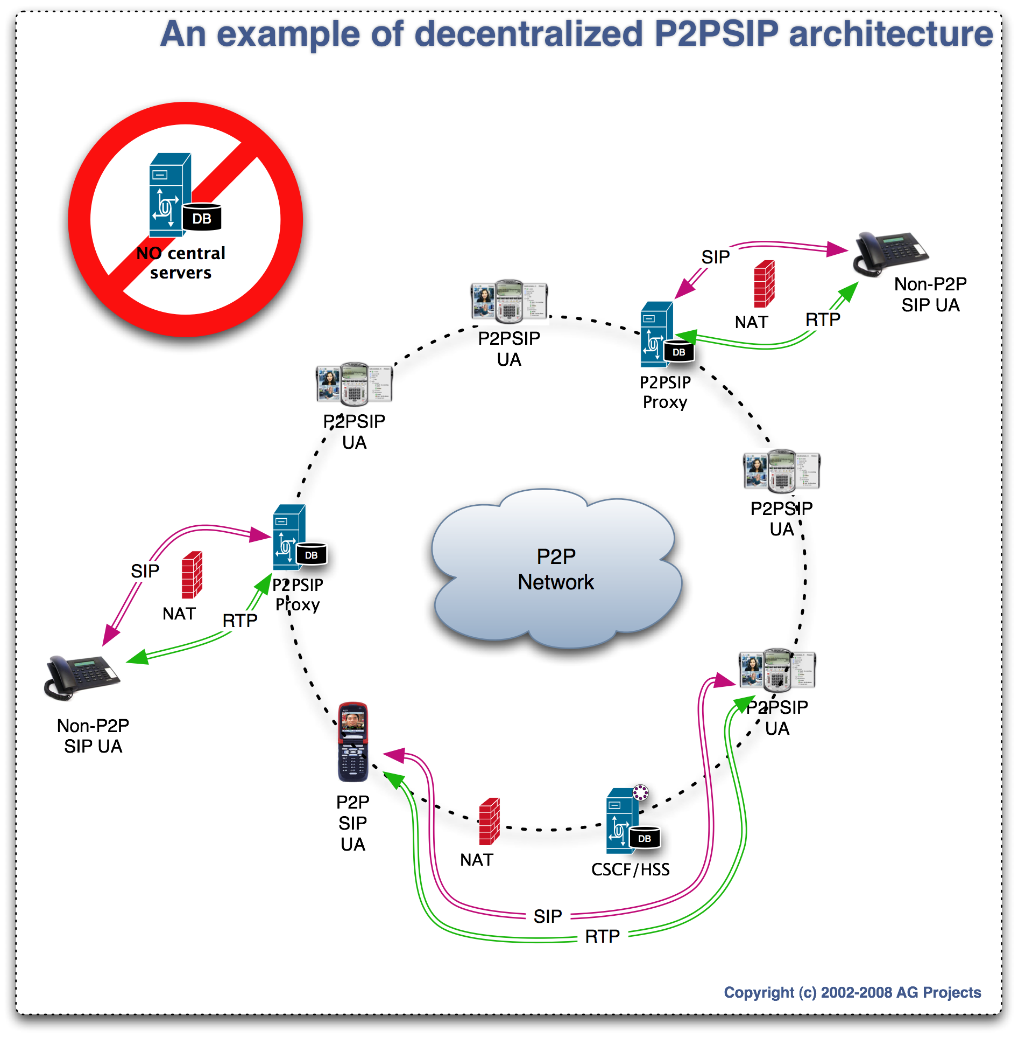
In a traditional SIP or IMS deployment, a single, or small number of tightly coupled, servers provide various services to the endpoints, including storing end-user data, performing registrations, routing calls and providing services ranging from simple voice mail to complex next generation multimedia services like presence or multi-party conferencing. At the heart of P2PSIP is a notion of providing a distributed "fabric" of devices that are able to provide these same services and functionality with little or no centralized infrastructure.

There are many types of Peer-to-Peer (P2P) Technology. P2PSIP is unique in that it provides a conceptually simple, standards-based mechanism to distribute functionality, leveraging the power of clusters of devices, rather than a single centralized box. These devices work together, collectively, to replace the resources and services that would be provided by the centralized server.

As much as possible, existing technologies, protocols, and architectures are leveraged to harness the advantages of P2P while ensuring that full advantage is taken of the extensive work that has gone on to date in the development of standards such as SIP, DIAMETER, and ICE. It is an effort to produce a P2P framework for communications (including voice, IM, video, and others) that is compatible with today's equipment and standards. By taking this approach, existing product lines can be augmented to include P2P functionality; existing carriers can incorporate (incrementally!) P2P approaches, and users and enterprise administrators can be more comfortable knowing that the solution works with other equipment and is implemented in an open and transparent manner.

To date, most of the work on P2PSIP has focused on pushing as much functionality as possible all the way to the end-user devices, enabling them to collectively provide the capabilities that would traditionally reside in centralized servers such as proxies, registrars, feature servers or soft-switches. The same principles can also be applied, however to the large number of servers used in an operator-controlled network. Rather than pushing functionality completely to the edge, P2P technology can be used as a mechanism to allow a number of servers to share basic information, providing for high availability, replication of information, and improved reliability.

P2P (and P2PSIP) fundamentals
It is important to realized that P2P is essentially a different way of distributing the "load" of a system architecture, whether the load to be shared is CPU processing, resource storage, or call control. As such, P2P systems don't eliminate the work that would be done by a centralized device in a traditional client-server architecture, but rather distribute that work differently, pushing the functionality to the edge. As a result, there some advantages to a P2P architecture (for example improved scalability and reliability) and some areas where a conventional CS system may be better (for example number of hops involved to route a message).

Every P2P system provides the following basic features and mechanisms:

- Self-organization: P2PSIP systems provide a way of taking a collection of peers and allowing these peers to connect to one another in a mathematically structured way without coordination from outside – in other words, no manual provisioning or central control is required to organize the peers and determine where in the fabric they should be placed. The resulting collection of connected peers is referred to as an overlay. As new peers join, they query the existing peers to determine their location within the. As peers are added or removed from the fabric (a process known as joining or leaving the system), the fabric is able to determine how the structure changes, both in terms of how resources are stored and how the peers communicate with each other. This behavior is referred to as "self-organization".
- Routing: P2P systems may have hundreds of thousands or even millions of peers. In such large systems, it isn't possible for every peer to be connected directly to every other peer. The P2P algorithm used helps to determine a very small subset of other peers each peer connects to and provides mechanisms to ensure that through this small subset every other peer can be reached. This is achieved collectively; with some number of intermediate peers being used to route messages (or provide "next hop" information) between source and destination peers. Most P2P algorithms provide a mathematical guarantee of the performance of this routing. Many common systems ensure that no more than log₂(n) hops will be required to route a message, where n is the number of peers deployed in the system.
- Resource Distribution: P2P systems provide a mechanism for mapping resources onto the fabric, determining a particular peer (typically more than one for redundancy) that will be responsible for providing a resource (storage, service, etc.) Ensuring that all peers understand and share an underlying set of assumptions of where resources will be located. Most approaches strive to make this distribution "fair", where fair may be evenly distributed, distributed on the device most capable of providing that service, etc.
- Join and leave: The peers together perform some service that is normally provided by a central device. As an example, they might store registrations for a phone system that would normally be stored by a SIP registrar. As new nodes join or leave, the P2P algorithm is responsible for ensuring that some fraction of the distributed resources stored by the existing peers (in this example, registrations) are passed to the new peer. Similarly, as a peer leaves, the algorithm will ensure that the resources that peer is responsible for are passed to another in the system. The join and leave operations are handled automatically by the network without disruption of other resources and do not require provisioning or central coordination as in a client-server environment.
- Lookup, Get and Put When a peer wishes to locate a particular resource, the resource distribution and routing mechanisms defined by the P2P algorithm can be used to determine which other peer is responsible for storing that resource (or providing the desired service) and to locate and communicate with that peer, even if it is one of millions in the system. Again, in most mathematical algorithms used in P2P, performance of at least log₂(n) can be guaranteed in looking up resources as well. Once the responsible peer is located, a resource can be stored or retrieved from that location, providing an efficient, scalable, and fully distributed lookup system. Note that a traditional, client server lookup can usually be completed in constant time, simply requiring a message to be sent to the central server, rather than through several hops. As with most things in life, nothing is free, and P2P's advantages come at the cost of slightly higher lookup hop counts.

The major advantages offered by a P2P approach include:

- Redundancy/Reliability: Resources or services can be located on more than one of the devices that make up the fabric. Again, this is mathematically structured, so that finding these replicas can be done efficiently and deterministically. By combining this with the load balancing aspects of the system, this allows for nodes to fail, using replicas in their absence, and to propagate the replicas back to the original locations later, resulting in a high reliability system.
- No Single Point of Failure: Because no single peer is storing all of the data, there are typically several ways to route messages through the fabric, and resources are replicated on multiple peers, the failure of any single peer cannot bring the network down. In fact, in many systems, large fractions of the peers can fail and the system will still function.
- Ease of Configuration: For certain applications, the self-organizing aspect of P2P can enable systems to be configured more easily. For example, an ad-hoc system can be quickly set up, with no need to provision a central box in advance for the devices joining the network.
- Scalability: Since P2P systems use a fixed algorithm to determine what information each peer is responsible for; each new peer that is added becomes responsible for storing information or providing services as well. Each new peer brings new demands on the system, but also provides additional services or storage. In this way, P2P systems have scaling properties that make them very attractive both to remove servers, and as a technique for building high availability clusters of servers.

P2PSIP is an approach to P2P that offers the following advantages over other, earlier mechanisms that have been proposed or deployed:

- Standards-based: P2PSIP systems are being developed within the IETF, with an eye towards standardizing the protocol used by the peers to connect. This enables administrators, developers and end users to interchange elements, ensure they work together, and most importantly, understand and control the traffic on their networks – something not possible with non-standard P2P systems.
- NAT traversal: P2PSIP systems are using the IETF NAT traversal suite (STUN/TURN/ICE) to provide NAT traversal function, a critical function for assuring high success rate of communications over any network topology connected today to the Internet.
- Security, Authentication and Charging: P2PSIP systems have been designed to be highly secure, including mechanisms to verify the identity of users, verify that peers are authorized to join, and even provide centralized authentication, if needed, all while still allowing other aspects of the system to be fully distributed While not defining new mechanisms, the design of P2PSIP uses conventional SIP to set up and manage calls, meaning that existing work to allow for security, authentication and charging done by the SIP and IMS community can be leveraged in a P2PSIP architecture.

P2PSIP standards activities
P2PSIP has been a topic of interest in the IETF for several years. The topic was first proposed to the SIPPING Working Group (WG) by David Bryan in January of 2005 [], and in the ensuing years, interest has snowballed. P2PSIP is now embraced by the IETF as an official WG [], and has met three times to date. The primary work items the group has been chartered to address include:

- Development of a "Concepts and Terminology" document , which will explain what P2PSIP is, and the terms used by the WG to describe concepts. Because the topic is quite new, many new terms have been invented for concepts, and some cohesion is required among WG items. Additionally, the structure of the components of P2PSIP needs to be outlined. This document addresses these topics.
- Development of a "Peer Protocol Specification", which will document the protocol spoken between the peers that make up the fabric. At the date this article was published, the form this document will take was still a topic of debate.

The group is very active – in several of the recent IETF meetings it has been the best attended of all working groups, with approximately 250 attendees. Many other topics are of interest to the community, if not yet formally accepted as items the group will work on, including a client protocol specifying how non-peer devices could query the network using something other than SIP, applications scenarios descriptions, and usage documents.

Additionally, there is a great deal of work on how to incorporate P2P into SIP and IMS networks.

P2PSIP architectures
The following are all examples of ways that have been proposed to structure P2PSIP systems:

- P2P software is installed on a collection of endpoints (from a few dozen to millions). These endpoints each store a fraction of the registrations in the telephone system. A user wishing to call another user queries the collection of endpoints, eventually locating the particular phone that stores the location of the party that is attempting to be reached. The call is then placed directly between the devices. The collection of devices in this case can completely replace the functionality of the registrar and proxy, and potentially any feature servers in the system. In such an approach, the only "centralized" component that is required is a gateway or SIP trunking infrastructure.
- A system of tens to hundreds of SIP Proxy/Registrar uses a P2P mechanism to share registration information between them. When a new registration is received, the proxy mathematically selected by the P2P algorithm stores that value, regardless of which proxy received the message. Similarly, when a query to place a call is received, the collection of proxies is queried to locate the information. A user can contact any proxy to get the answer, although any other proxy may store the information and a minimum number of Proxies is involved in each call setup. Similarly other services like Voicemail and Presence can be scaled up in a similar manner in a cost effective way.
- A hybrid solution, where some call control is distributed, but other aspects (perhaps billing or authorization) is centralized, as would happen in a traditional deployment.

It is also worth mentioning that there are some other things that are occasionally described as "P2P" by other groups or by vendors in the SIP community, but are not the same as the definition of P2P discussed by the P2PSIP WG at the IETF. Some examples include:

- The basic functionality of SIP. If you simply configure two SIP devices to connect directly to each other, this has been referred to as "P2P" mode, in the sense that no central devices or servers are being used to route the call. However, this isn't truly a P2P deployment in that the phones are not working together to provide the functionality the central server would have provided – such a configuration does not scale beyond two devices (or as many devices as you can remember IP addresses for). Similarly, describing a system where "the media flows directly between the peers", while a central box provides registrar and proxy functionality – the standard functionality of SIP – is sometimes called P2PSIP. In these cases, this functionality has always been available in SIP and is not what we refer to as P2PSIP.
- Another mode of operation that has been referred to as P2P is having each user in a phone system also provide a phone line for collective use of all callers. If I choose to place a call, a user with a phone line that can complete that call freely or at very low cost is located, and the call is placed using their line. [,] While this type of resource sharing can be thought of as P2P, it is P2P in a different way, in that the phone lines, rather than the call control, are being distributed. A central server is still used to complete calls.

Building a Call Control platform based on a P2P fabric
Once a P2P basic fabric exists for distributing services, it is straightforward to use it to develop call-control services used by the IMS. We'll talk a bit more in a moment about using this in an IMS deployment, but first, let's take a look at how this fabric can be used to replace a registrar and proxy in a traditional SIP deployment of just a proxy/registrar and a few phones.

Each phone, in addition to supporting traditional SIP, is enhanced by the addition of the P2PSIP stack. As such, each phone, once connected to the fabric, can now mathematically determine where in belongs, relative to the other devices, and what resources (in this case, we will discuss only registrations) it should store. It also can use this same mathematical algorithm to easily locate the peers that will be storing a particular resource. In this case, the resource being stored collectively is the registrations, and thus each device will store some number of registrations. The most common mechanism to distribute this service is a hash table. Each users name or phone number is hashed to produce a unique signature within a known, finite hash space. The various devices making up the fabric split and share the hash space; each storing the registrations that hash to a particular interval that device is responsible for.

When the first phone joins, it realizes there are no other peers, and starts a new P2P node. At this point, it is responsible for storing all resources in the fabric. A registration for the user of that phone, mapping from the extension to the IP address of the device, is generated, hashed to produce a location to store it in, and stored in the fabric – at this point, that first (and only) phone.

When a second phone joins, it sees there is an existing node and joins. The new phone now controls some fraction of the resource space. A new registration is generated for the new phone's user, hashed, and stored in the fabric. Statistically, it is likely that one registration is stored on each phone, although in theory both could reside on the same device. Also, redundancy is used to ensure that multiple copies of the hashed resource (using different hash techniques to provide different storage locations) will be stored in the fabric.

Each new phone repeats this process. As it joins, it takes over a small fraction of the hash space, and stores the registrations that map to that region. It also adds a new registration for the user of that phone. As peers come, the cluster gets larger, and registrations are moved to the new peers. As they leave, the peers hand off their resources along with the slice of hash space they control, or in the event of a failure, replicas serve until the failure is detected and resources propagated from the replicas to correct for the missing information.

When a call is placed, a similar mechanism is used. The address of the called party is hashed, and the routing algorithm of the cluster is used to locate the responsible peer, who stores the registration. Since each peer only knows about some of the peers in the system, intermediate peers will either route the message on the sender's behalf, or will provide a "next hop" for the location of the peer. If the search fails, replicas can be consulted. The peer provides the registration, and the caller now has the IP address of the remote party's phone. A normal SIP call can be placed between the devices at this point.

Cost analysis of P2P primitives in relation to classic scalability and high-availability solutions
Having described the concepts that form the base for P2PSIP, we can now look at how these concepts can be used for the benefit of IMS. In particular, P2PSIP can help with ensuring high availability of resources, and helping a system scale in a simple way, while being designed from the outset to work with SIP. Note that while we will talk primarily about how this would be useful in an IMS deployment, there is nothing unique about IMS in how P2P concepts can benefit the solution. Any large-scale system consisting of a large number of devices, including a traditional non-IMS SIP network would benefit from a similar approach. SIP deployments and the IMS are unique in being able to leverage the "SIP friendly" aspects of P2PSIP directly, based on it's SIP lineage.

High availability
Traditional telecom infrastructures, SIP and IMS included, aim to provide high availability of resources and services for the end-users. The infrastructure is considered critical for reliably performing sensitive services like emergency calling, and malfunctions in a high availability system have to be carefully taken into consideration both by the designer of the systems and the operator using them.

The high availability aspect is a well-understood field of engineering in the telecom industry. The generic way to solve this problem was to design a resilient system for each separate function that has reserve resources to fallback to in case of a certain component failure. An example of a resilient system is a clustered database that employ several mirrored servers; should one server fail the other can take over the load originally associated with the one that failed. This is also known as cluster technology.

There are several disadvantages posed by cluster technologies. Among the most important are:

Need for monitoring. It is common for the operations department of a provider to closely monitor the health of its clustered systems 24/7. While a cluster system has a degree of high availability by design, it can usually sustain only a single or few component failure(s) at a time. A secondary failure on a reserve server can bring down the service offered by the cluster completely. It is therefore essential that a failure is quickly detected and the reason(s) for failure removed quickly before a secondary failure occurs. Hence, specialized systems and costly trained personnel are dedicated for monitoring activities.

Inefficient use of resources. Typical cluster designs employ a master/slave schema, by which the slave machine sits idle waiting for taking over in case of failure of the master. This means a 50% waste of available resources, as a slave system may not be used until a disaster occurs.

Non-deterministic fail-over. While the design of a cluster assumes the members will be able to take automatically over each other’s function, in reality this seldom occurs as planned. There are many problems experienced in field deployments that can prevent a correct fail-over. These problems can include different or out-of-date software versions of the cluster members, unsynchronized data at the moment of fail-over, untested procedures, and inexperienced personnel that have seldom had the chance to rehearse a fail-over and the correspondent recovery processes. Additionally, after a failure and the associated repairs, the cluster has to be switched back to its original state, generating new possibility for service downtime.

Operational costs. Clusters usually have high costs associated with them. They typically make use of redundant instances of expensive hardware with redundant components. The price tag of personnel specialized in troubleshooting and recovery of these clusters can also be very large. For example, the cost of maintenance associated to a simple hard-disk repair in a high-availability server-using RAID controller and multiple disks usually is higher than the cost of the hardware itself over its lifetime. This leads to high capital expenses, and even higher operational expenses.

Scalability
Services related to telephony and real-time communications must be designed to scale for millions of end-users. It is likely than an IMS deployment will need to scale to at least the size of a country. This means millions of active subscribers connected to a centralized system. IMS is a complex architecture with many discrete components and interfaces.

Many of the IMS call flows involve many components and use many interfaces and databases to fulfill the accessed service. For many portions of the IMS architecture, the implementers are responsible for finding the best way to implement scalability. Each call flow must identify the bottlenecks associated with heavy usage and find a solution for each. Many interfaces mean many ways to solve scalability for each of them.

The scalability issue has been addressed by the telecom industry in a number of ways. For example, high-density hardware combined with the use of clusters and load balancers have been successfully deployed in TDM/ATM networks for decades. Another technique to achieve scalability is through static provisioning. With static provisioning, devices are preconfigured to each use a different set of servers. Dedicated servers are allocated to serve different cities, parts of a country, or regions. The data containing the subscriber information or the routing logic of the switching equipment (such as dial plans) is replicated across multiple sites using synchronization mechanisms, usually proprietary to a particular vendor. The provisioning of the servers and various customer premises devices form therefore integral part of the operator operational activities.

In addition to the reliability, opex and capex costs discussed above, here are several other disadvantages of using classic technologies for achieving scalability of IMS.

Load balancers are points of failure. The load balancers usually are able to increase the capacity of a certain function by employing light weighted service logic to distribute requests to a server farm behind them. The capacity increase by the use of a load balancer usually ranges from a simple multiple to one order of magnitude. For example, a stateless SIP load balancer might be able to load balance requests to ten transaction-stateful SIP Proxies behind it. After a certain load, the Load balancer itself becomes subject to the same issues that initially were supposed to be solved by its addition. Load balancers are expensive and constitute major single points of failure.

Static provisioning is unreliable and error-prone. Static provisioning implies major changes whenever customers or their devices must be assigned to specific servers or locations. Data has to be prepared and uploaded to carefully identified devices. This requires time-consuming planning as well as coordinating with many third parties these changes at a later date. Preserving data integrity across multiple locations is an unreliable and costly technique. Specialized database backend using replication techniques can solve this problem partially, but only at a high operational cost. This mechanism does not allow for improving the speed of changes under the increased load caused by the addition of new customers. Static provisioning can also cause problems if, for whatever reason, a different server needs to be consulted instead.

SIP Compatibility
Because P2PSIP has been developed with SIP as the primary application, an emphasis on making deployment of SIP systems simple has been emphasized from day on. P2PSIP currently specifies no changes to the SIP messages used for call signaling. While there may be extensions in the future, the emphasis is on minimizing changes to SIP for maximum compatibility. As another example, there has been extensive discussion within the working group about how to access P2PSIP systems, including locating other devices and routing calls, using simply SIP primitives. Mechanisms for NAT traversal (ICE) are being reused in P2PSIP as well.

Because IMS is based on SIP, these design decisions mean that integrating P2PSIP into an IMS deployment should be more "pain-free" and require less new code than any other P2P approach currently available or being proposed, and should allow for a smoother (and more gradual) transition if an IMS vendor or operator decides to incorporate P2PSIP technology into their architecture.

Can P2PSIP and the IMS compliment each other?
While it is clear that there are some proposed uses of P2PSIP that are at odds with the IMS (for example in deploying free, completely open communications systems on the global Internet), there are many ways that P2PSIP and IMS can be combined to produce a product that is "greater then the sum of the parts"

P2PSIP helps by eliminating the complexity aspects of the IMS while solving the high-availability and scalability issues of IMS.
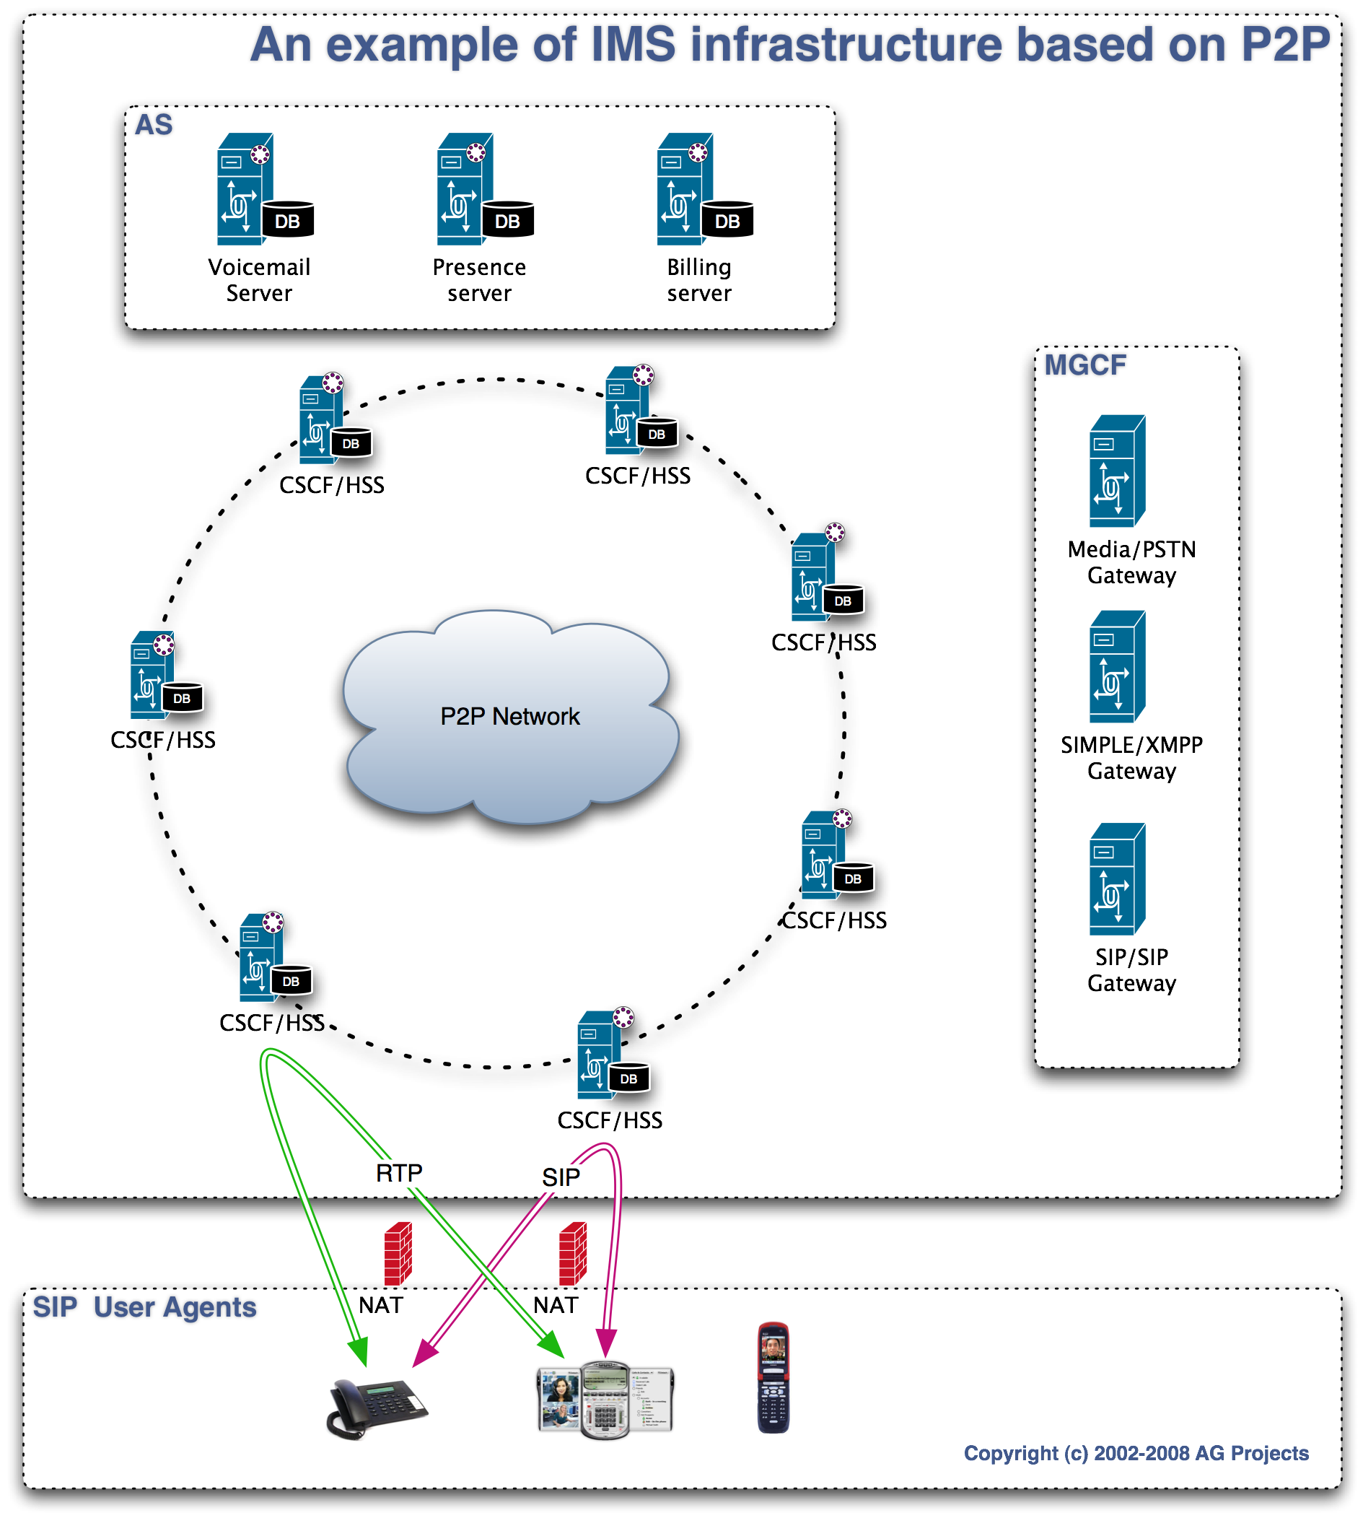
As mentioned in the previous chapters, P2PSIP has a primitive called Leave. This is equivalent to a failure in the telecom terminology. The way the failure is dealt with by P2P it is however completely different and we believe superior to other reliability models that could be used in the IMS. Because dealing with failures has been moved in the network protocol itself, it means that the need for monitoring and human intervention is significantly reduced. The network is able to detect and "heal" itself faster than any human operator can. It is also deterministic in the way it the way it deals with failover.

Many IMS functions that require high availability and must quickly recover from failure can benefit of P2P. Such functions are the database holding the subscriber information, the SIP Proxy and SIP Registrar functions, the application servers that provide value added services. Any function in which information is retrieved based on a known key (such as the subscriber SIP addresses) can be easily ported to a P2P environment.

By applying P2P concepts to solve the high availability of IMS functions, the operator can achieve major costs reductions for operating the IMS.

Another P2PSIP primitive is Join. Join is the equivalent of increasing the capacity of a service provided in a telecom environment. In a traditional telecom deployment, even one that is IMS based, capacity increase is realized by carefully planning, reengineering, configuring, testing and deploying equipment and software by expert technicians, often at great cost. Such activities must usually be liaised with multiple vendors and an integrator, all adding to the costs of the upgrade. By using P2P in the core of the architecture the costs related to capacity increase can be significantly reduced. P2P Join allows additional servers, and thus additional capacity, to be added to the network transparently, with an automatic operation handled by the protocol. Adding new services may require additional development and engineering, but adding additional processing power to a P2P cluster requires no new engineering and no downtime.

The IMS operator can also achieve a near-perfect distribution of resources between different racks, data-centers, cities or countries, as P2P systems use mathematical mechanisms that statistically guarantee that resources are fairly distributed. Assuming sufficient connectivity with low latency is available, systems can even be balanced across WAN links, rather than just physical LAN links as in the case of clusters.

The Self-organization primitive of P2P provides an innovative way to deal with join and leave events. Because the network has its own organization and clustering primitives at the application layer, a truly access independent IMS can be implemented irrelevant to the access technology used in the core or last mile access. IMS can be fully distributed in multiple physical locations that automatically share the load generated by the end-users.

The Routing primitive provided by the P2P protocol, along with replication techniques, assures deterministic routability of service requests between the servers even in case of server failures, without any manual intervention. Because the routing is performed using mathematical formulas, it is not subject to provisioning of static data and the hassle associated with manually replicating such data across multiple nodes.

Unprecedented scalability can be achieved by using P2P. As the total capacity of the network scales with the amount of nodes available, the incremental costs of upgrade is small compared to major reengineering. The major monitoring function required for a P2P network is the amount of nodes available to serve a specific function.

High economy-of-scale cost savings can be realized by using of-the-shelf commodity hardware instead of highly available servers. It is cheaper to replace standard hardware rather than repair highly available hardware. A defective server can be simply replaced by booting a standard P2P software build; the server will provision itself by communicating with the other peers in the cluster, and become part of the operational network without any manual setup.

Implication for End Devices
In a combined P2PSIP/IMS approach, little (if any) of the capabilities will be pushed entirely to the endpoint. There are several reasons for this. First, many of the devices that are envisioned to be deployed in the IMS are mobile devices. The requirement that these devices use as little power as possible means that these devices would be poorly suited to being used as peers, since the additional transmission power needed to serve requests can compromise the life of the battery. Similarly, these devices are likely to have low bandwidth capability, and are more likely that fixed devices to come and go on the network. Rapid join/leave cycles of devices in the fabric is a condition referred to as churn, and is undesirable in a P2P network, as it leads to a greater dependence on replicas for locating information, increases the load on all peers as resources are moved, and leads to less stable routing.

Because of this, mechanisms are being explored to allow the devices to communicate with the fabric, either using conventional SIP or by using a client protocol, designed to query and store information without being a peer.

In the case of IMS and P2PSIP, it is more likely that, at least initially, P2PSIP will be used between the servers, leaving the relationship between the end devices and the servers unchanged. This provides the additional benefit of leaving the current authorization and charging mechanisms in place, while leveraging the advantages of P2P. As the technology becomes more established in the IMS, more of the functionality may move to the edges, while still centralizing aspects required to maintain control of the network.

Applications of the IMS to P2PSIP
P2PSIP has been designed from the outset to reuse as much existing infrastructure from other protocols and architectures as possible. There has been a concerted not to "reinvent" the wheel. As such, basic aspects of SIP have not been reinvented, but this also means that certain aspects of a telecommunications system – most notably the charging functions – have not been addressed in P2PSIP.

As a result, those deploying even a purely P2PSIP deployment may find aspects of the IMS interesting to use in their systems. Servers and mechanisms for charging function can be integrated into a P2PSIP system when placing calls to the PSTN, for example. When peering between two isolated P2PSIP deployments, the mutual authentication mechanisms proposed by the IMS can be applied.

Conclusions
While it is tempting to dismiss P2PSIP as a competitor to IMS – something that will enable applications that will lead to the downfall of today's carriers, there are aspects of P2PSIP that can be easily integrated into an IMS architecture, resulting in a system that is easier to manage, scales easily, and is more resilient to faults. It is certain that the relationship between P2PSIP and IMS will be complex. It is true that P2PSIP can be used – without the IMS – to deliver many of the same services that are proposed for the IMS, and such solutions are certain to emerge. But P2PSIP and the IMS can also live together in some deployments, allowing the advantages of P2PSIP to be paired with IMS.

A strong hybrid network, combining these aspects of P2PSIP with the authorization, charging, QoS, and new application deployment ease offered by IMS, is a very attractive design for a next-generation network. All savings associated to operating an IMS based on P2P principles can be passed down to subscriber turning IMS into a cost effective way to provide reliable services to millions of user while staying competitive with other Internet players.

Authors

David A. Bryan, CEO SIPeerior Technologies

David is a recognized thought leader in the area of P2PSIP and is co-chair of the IETF P2PSIP Working Group. He has published numerous IETF drafts, industry trade articles, and academic papers on the subject and is active in the SIP community. Prior to founding SIPeerior, David was co-founder and CTO of Jasomi Networks, a pioneer in the SIP Session Border Controller (SBC) market, which was sold to Ditech Communications in 2005. David previously worked for Cisco Systems via its acquisition of Vovida Networks, where he led a team of developers creating the first open-source softswitch. David holds bachelor's degrees in Computer Science and Physics from Richard Stockton College in NJ, as well as a master's degree in Computer Science from The College of William and Mary.

SIPeerior Technologies is the leading provider of standards-based, OEM software solutions designed to enable server-less implementations of real-time communications applications. Our revolutionary P2PSIP technology provides our customers with the ability to quickly bring new products and services to market that take advantage of the efficiencies of a peer-to-peer environment. The operational and capital savings associated with our technology mean that our customers can not only offer new services in new markets, but because of our commitment to standards compliance, can help decrease the costs of deploying their existing SIP-based solutions. SIPeerior was founded in 2006 by a team composed of industry veterans, serial entrepreneurs, and technology experts. SIPeerior is a privately held company with headquarters in Williamsburg, Virginia, USA.

Adrian Georgescu, Founder and CEO of AG Projects

Based in the Netherlands, AG Projects is a leading European company supplying cable operators and Internet service providers with turnkey SIP infrastructure systems. AG Projects focuses on the delivery of scalable SIP infrastructure that complements fiber to the home deployments, triple play and converged fixed/mobile communication services. Delivery includes the analysis of requirements, tailoring of solutions to meet the requirements, project management, training and support activities.

Adrian is an advocate of IETF standards, member of OpenSER management board, founder and co-chair of the Dutch ISOC SIP Special Interest Group. Prior to starting of his own company, Adrian had accumulated experience with Esprit Telecom, GTS, Ebone and KPNQwest. Adrian's expertise is the design of high-availability infrastructures, addressing and numbering systems, signaling protocols, provisioning and mediation systems, implementation of disaster recovery plans. Adrian has received in 1996 a degree in Electrical Engineering from Faculty of Electrotechnics at the Polytechnic University of Bucharest, Romania. Adrian is closely involved in the development of Open Source software related to the adoption of SIP protocol. He personally contributed to and supported the development of projects like OpenSER, MediaProxy, CDRTool, OpenXCAP and MSRP-Relay.

References

Glossary

3GPP | 3rd Generation Partnership Project
AAA | Authentication, Authorization and Accounting
API | Application Program Interface
AS | Application Server
ARIB | Association of Radio Industries and Businesses (ARIB)
ATIS | Alliance for Telecommunications Industry Solutions
AVP | Attribute-Value Pair
CAMEL | Customized Application Mobile Enhanced Logic
CCSA | China Communications Standards Association (CCSA)
CDF | Charging Data Feature
CN | Core Network
COPS | (Common Open Policy Service)– RFC 2748
CS | Circuit Switched
CSCF | Call Session Control Function
Cx | Diameter interface for interactions between HSS and CSCF
DIAMETER | Successor to RADIUS – RFC 3588 – Need for Mobile IP
DSL | Digital Subscriber Line
ETSI | European Telecommunications Standards Institute
FMC | Fixed/Mobile Convergence
FTTH | Fiber to the Home
GSM | Global System for Mobile Communications
HSS | Home Subscriber Server
I-CSCF | Interrogating Call Session Control Function
IPSec | IP Security Protocol
IETF | Internet Engineering Task Force
IMS | IP Multimedia Subsystem
IP | Internet Protocol
MGCF | Media Gateway Control Function
MRFC | Media Resource Function Controller
MRFP | Media Resource Function Processor
MSF | MultiService Forum
NAT | Network Address Translation
OSA | Open Services Architecture
P2PSIP | Peer-to-Peer SIP
Peer | Any device that participates in a P2P (or P2PSIP) network
PRACK | Provision Response Acknowledgement (SIP Message)
P-CSCF | Proxy-Call Session Control Function
PSTN | Public Switched Telephone Network
PDF | Policy Description Function
Overlay | The collection of devices that make up a P2PSIP network
QoS | Quality of Service
RADIUS | RFC 2865 – Remote Authentication Dial In User Service
SCS | Service Capability Server
S-CSCF | Serving-Call Session Control Function
SEG | Security Gateway
SGSN | Serving GPRS Support Node
SIP | Session Initiation Protocol
Sh | User profile interface between HSS and AS
TTA | Telecommunications Technology Association (TTA)
TTC | Telecommunication Technology Committee
UE | User Equipment (IMS Terminal)
VCC | Voice Call Continuity
WIFI | Wireless Fidelity (IEEE 802.11)
WI-MAX | Worldwide Interoperability for Microwave Access, Inc (IEEE 802.16)
XCAP | XML Configuration Access Protocol

A P2P Approach to SIP Registration, draft-bryan-sipping-p2p-00, D. Bryan et al, January 2005, IETF Internet-Draft (expired draft, work-in-progress)
IETF P2PSIP Working Group Charter, http://www.ietf.org/html.charters/p2psip-charter.html
Concepts and Terminology for Peer to Peer SIP, draft-ietf-p2psip-concepts-01, November 2007, D. Bryan, P. Matthews, E. Shim and D. Willis, IETF Internet-Draft (work-in-progress)
AG Projects’ SIP Thor, P2P infrastructure for operators, http://ag-projects.com/SIPThor
Free world Dialup: http://www.freeworlddialup.com
OOMA, http://www.ooma.com/

